261-[NF]-Lab - Public and Private IP addresses

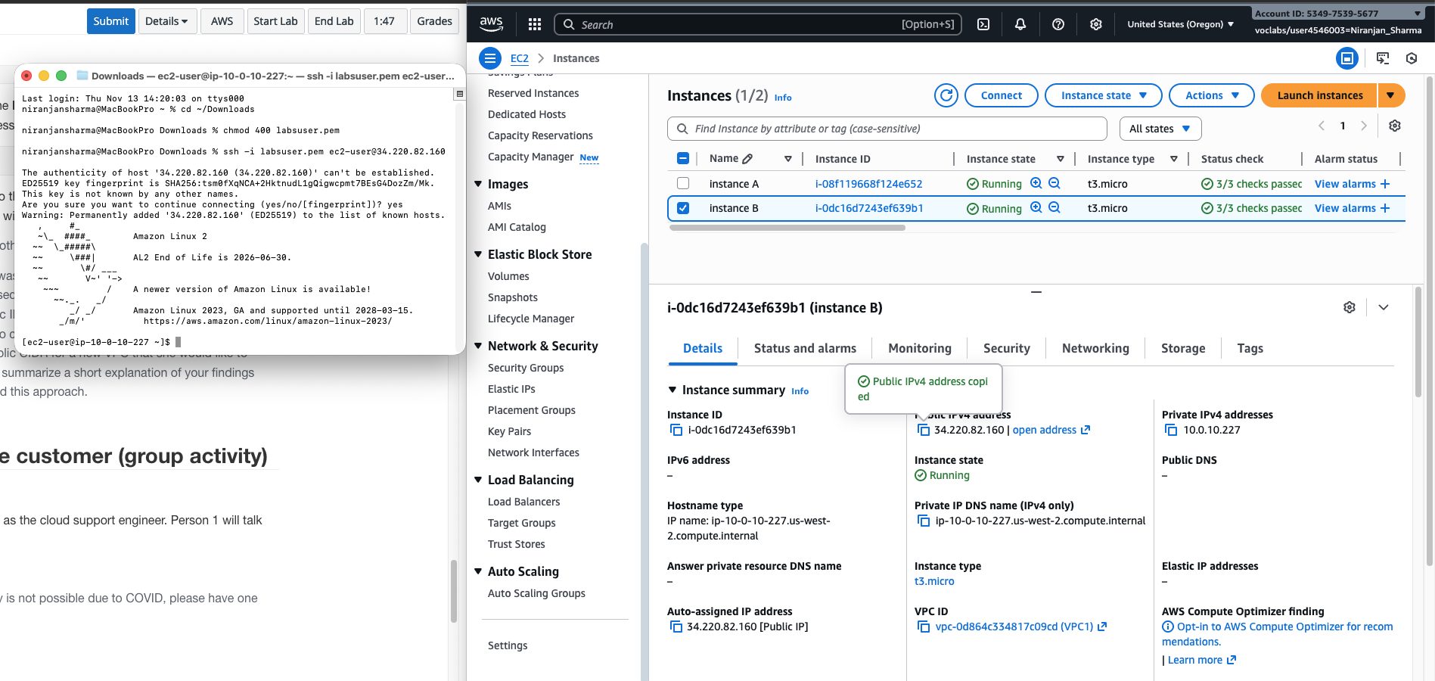

262-[NF]-Lab - Static and Dynamic and IP addresses

The client needs to associate a static public IP address (Elastic IP) with their EC2 instance so that the IP address remains constant when the instance is stopped and restarted.
